

Certificate
MANAGEMENT SYSTEM CERTIFICATION

This is to certify that
Quality Management System
Of
Shree Rudrabhoomi Fire Fighter
Office No. 11/12/13, Balaji Compound, Dayabhai Patel Road, Malad (E)
Mumbai-400097, Maharashtra, India

Complies with the requirements of
ISO 9001: 2015

This certificate is valid for the following activities related to:

Manufacturing, Supplier & Installation Services Of Fire Fighting Equipments, CCTV installation, Fire Extinguishers, Fire Alarm Systems And PPE’S

14.07.2018 14.07.2021 1043
Date of Issue Valid Until* Certificate No.

1st Surv.Due Before - 14.06.2019 2nd Surv. Due Before - 14.06.2020
Associates

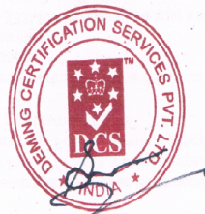
Association

Technical Director

DEMING CERTIFICATION SERVICES PVT. LTD.

For Further Clarification Of The Scope Of The Certificate, Validity
And The Applicability Of The Management System, Can Be
Obtained From info@demingworld.Com Website: www.demingworld.com
Astoria Park, 09-09, Tower E, 32, Lorong Mydin, Singapore - 416826

*Lack Of Fulfillment Of Conditions Set Out For The Issuance Of This Certificate And Timely Completion Periodic Surveillance Audits May Render This Certificate Invalid.

demingcert /demingcert demingcert demingcert


