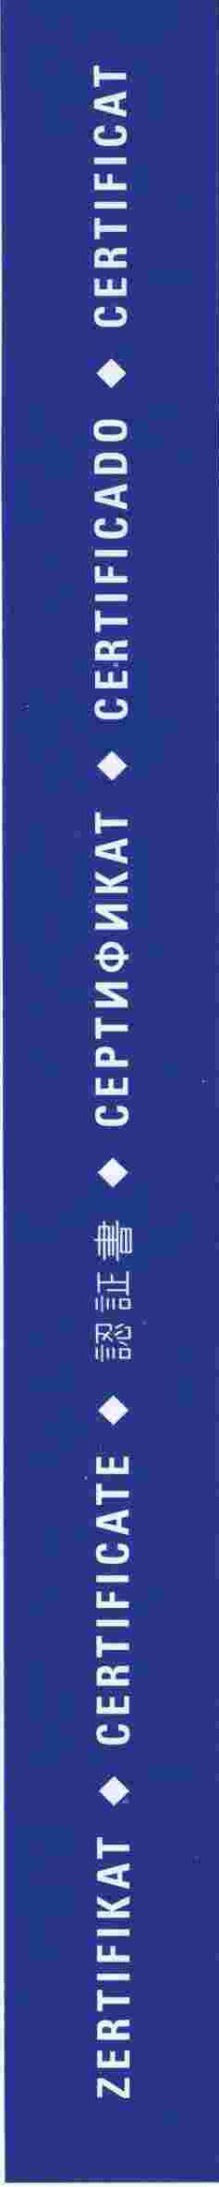
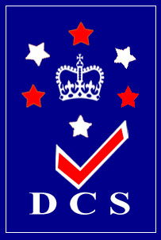
Certificate
This is to certify that
Management System
Of
MOTIBAGH WORKSHOP
Kamptee Road S.E.C Railway, Nagpur-440004, Maharashtra, India

This Certificate verifies that the above organization has been audited on the above address for scope as under and found to be in accordance with the requirements of management system.
ISO 14001:2015
Environment Management System

Scope of Work
Periodical Overhauling of Broad Gauge Coach, IOH of Bogies (BG) and Manufacturing of Bio-Digester Tank & Inoculum for Indian Railways.
14/09/2018 09/05/2019 10013-E-01160509
Date of Issue Valid Until* Certificate No.
Associates

Association

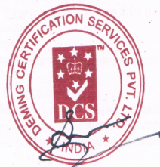

Technical Director
DEMING CERTIFICATION SERVICES PVT. LTD.
For Further Clarification Of The Scope Of The Certificate, Validity
And The Applicability Of The Management System, Can Be
Obtained From info@demingwold.Com Website: www.demingworld.com
Astoria Park, 09-09, Tower E, 32, Lorong Mydin, Singapore - 416826

*Lack Of Fulfillment Of Conditions Set Out For The Issuance Of This Certificate And Timely Completion Periodic Surveillance Audits May Render This Certificate Invalid.

demingcert /demingcert demingcert demingcert

Rev 01

